**Master Functional Document**

|  |  |
| --- | --- |
| **Application** | NGERP - Centra |
| **Service Bundle** | Master Management |
| **Service Request** | Sales Type |

**Description :**

Sale Type is used to categories document type by sales category .

**Workflow Process :**

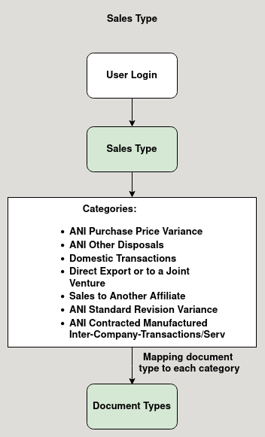

**Business Rules :**

* User can use this master to categories document type.
* There are 7 categories in sales type.
  + ANI Purchase Price Variance
  + ANI Other Disposals
  + Domestic Transactions
  + Direct Export or to a Joint Venture
  + Sales to Another Affiliate
  + ANI Standard Revision Variance
  + ANI Contracted Manufactured Inter-Company-Transactions/Ser